Nga Ba Giong Historical Heritage Park

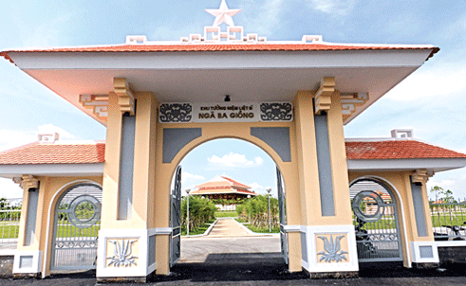
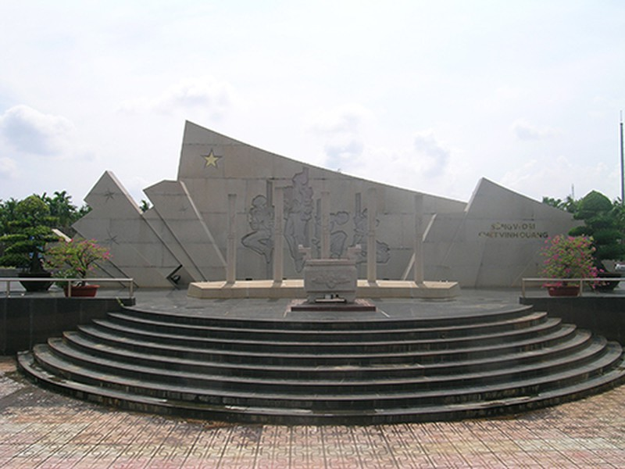
- Nga Ba Giong is about 10 hectares in Xuan Thoi Thuong Commune, in Hoc Mon District and was one of the French’s firring fields in the Indochina war.
- At this place 903 Communist soldiers were executed in 1940, icluding famous people like Nguyen Van Cu ( General Secretary of the Communist Party of Vietnam, and Phan Dang Luu ( Central Party Commissioner ).
- In 2002, this place was recognized as a national historical site .

